Urganch davlat pedagogika instituti 2026/2027-o‘quv yili uchun talabalarni ijara xonadonlariga
joylashtirish bo‘yicha ma’lumot

№ | Ijara xonadoni egasining F.I.Sh | Ijara xonadoni manzili | Ijara xonadonining geolokatsiyasi | Ijara xonadoni egasining telefon raqami | Ijara xonadoni narxi (kishi boshiga) | Ijara xonadoni fotosurati
1 | O'dakov Fayzullo | Pahlavon Mahmud ko'chasi 16 kvartal 202 xonadan | https://maps.google.com/maps?q=  41.566372,60.608624&ll=  41.566372,60.608624&z=16 | 93 747 52 80 | 400000 | 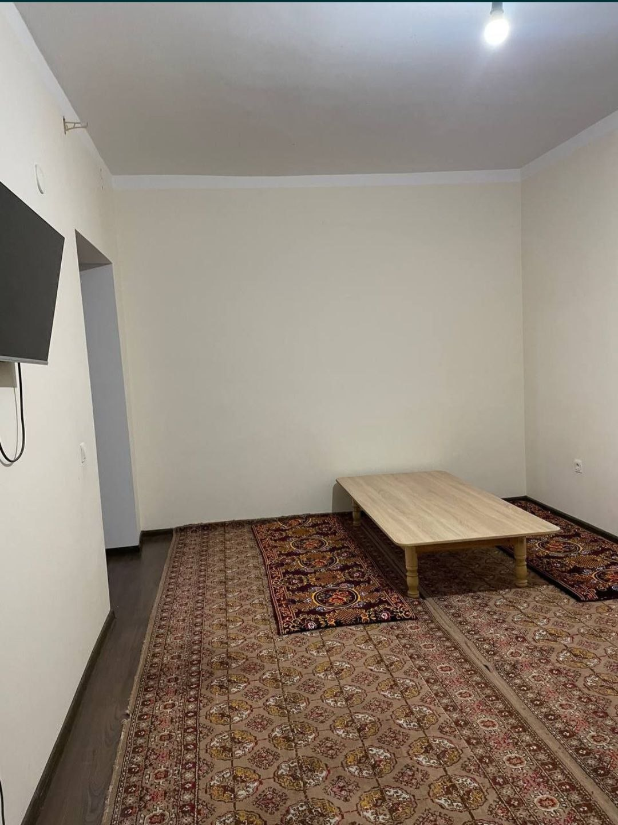 | 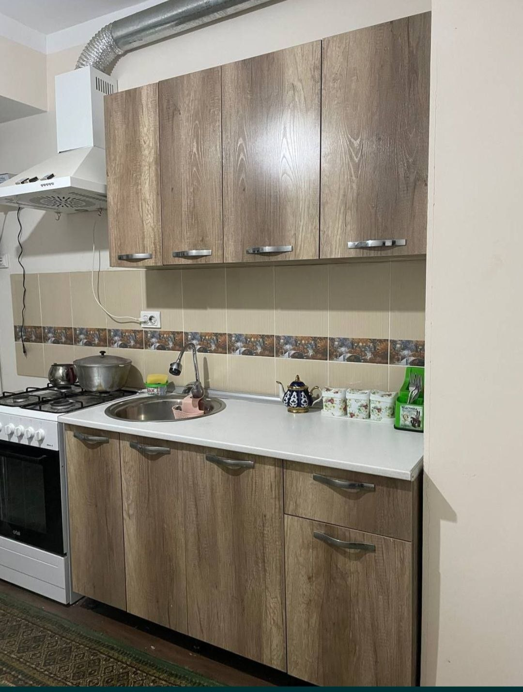
2 | Qalandarova Adolat | Tozabog' mahallasi 12-dom 19-uy | https://maps.google.com/maps?q=  41.562261,60.606798&ll=  41.562261,60.606798&z=16 | 91 984 71 21 | 450000 | 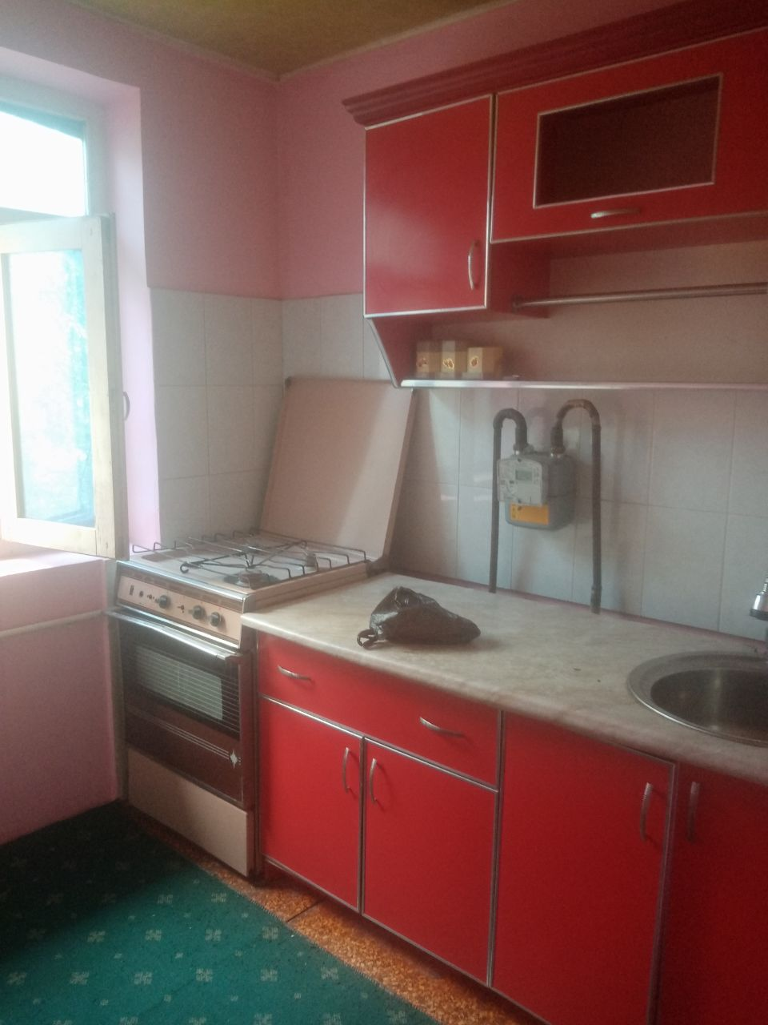 | 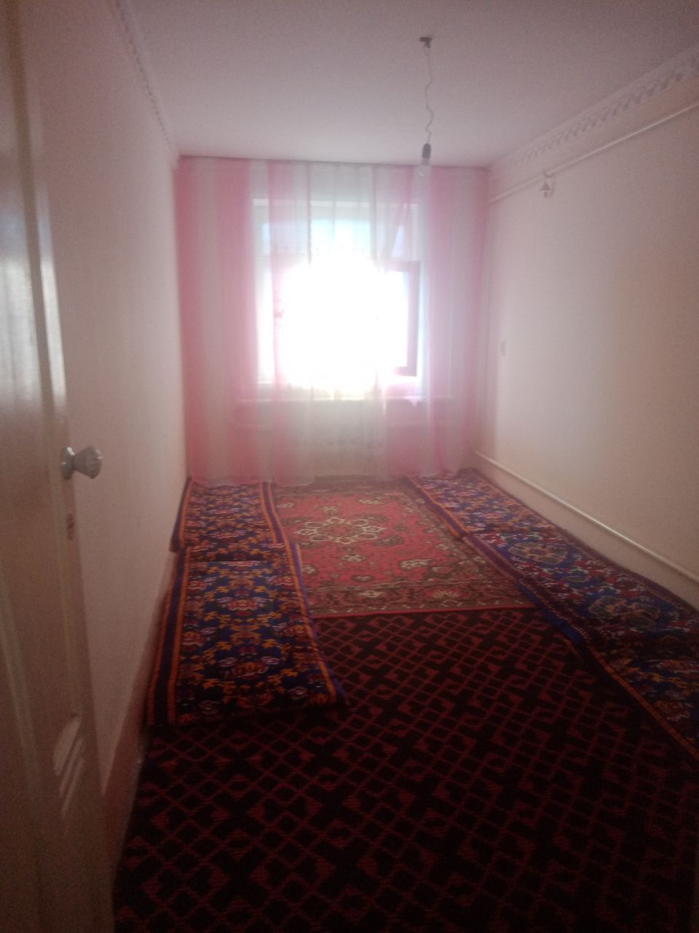
3 | Egamov Izzatoy | 4-daha 11-dom 20-uy | https://maps.google.com/maps?q=  41.568614,60.606651&ll=  41.568614,60.606651&z=16 | 97 452 30 32 | 400000 | 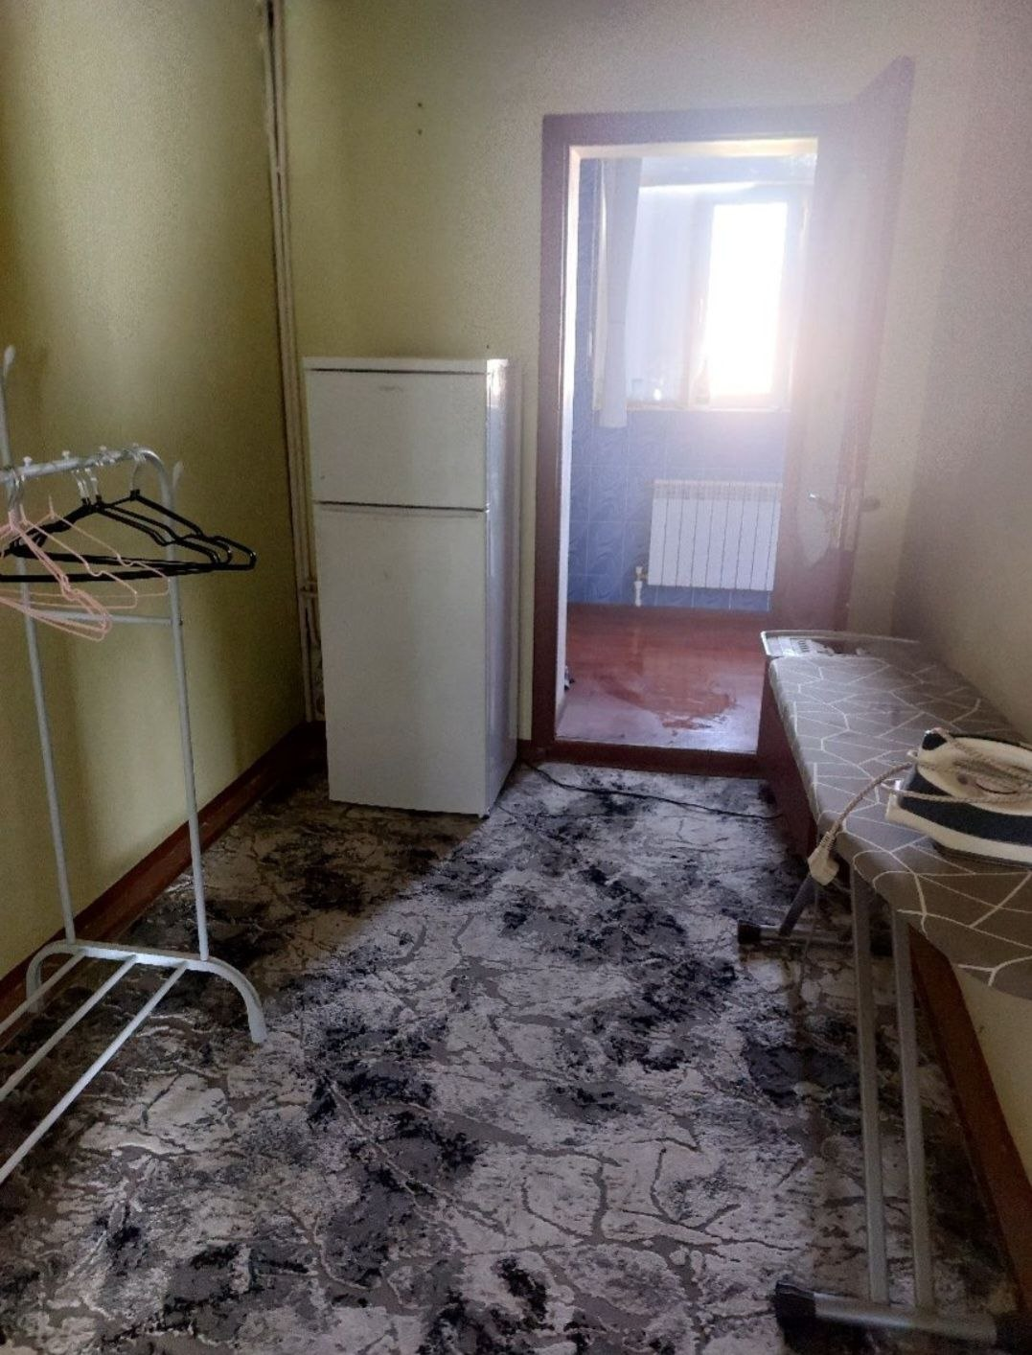 | 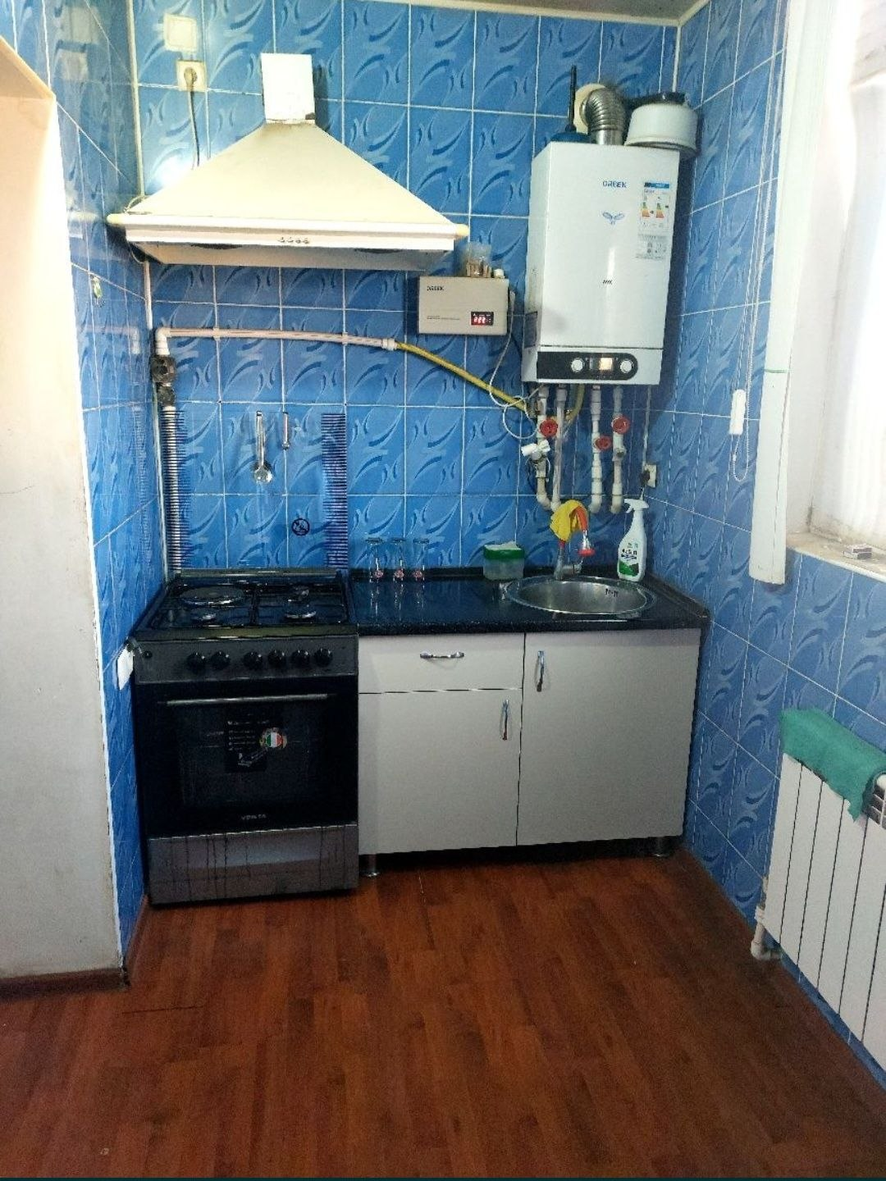
4 | Allaberganov Ruslan | Urganch shahar Baynalminal mahallasi 32-uy | https://maps.google.com/maps?q=  41.571257,60.611250&ll=  41.571257,60.611250&z=16 | 97 364 58 88 | 400000 | 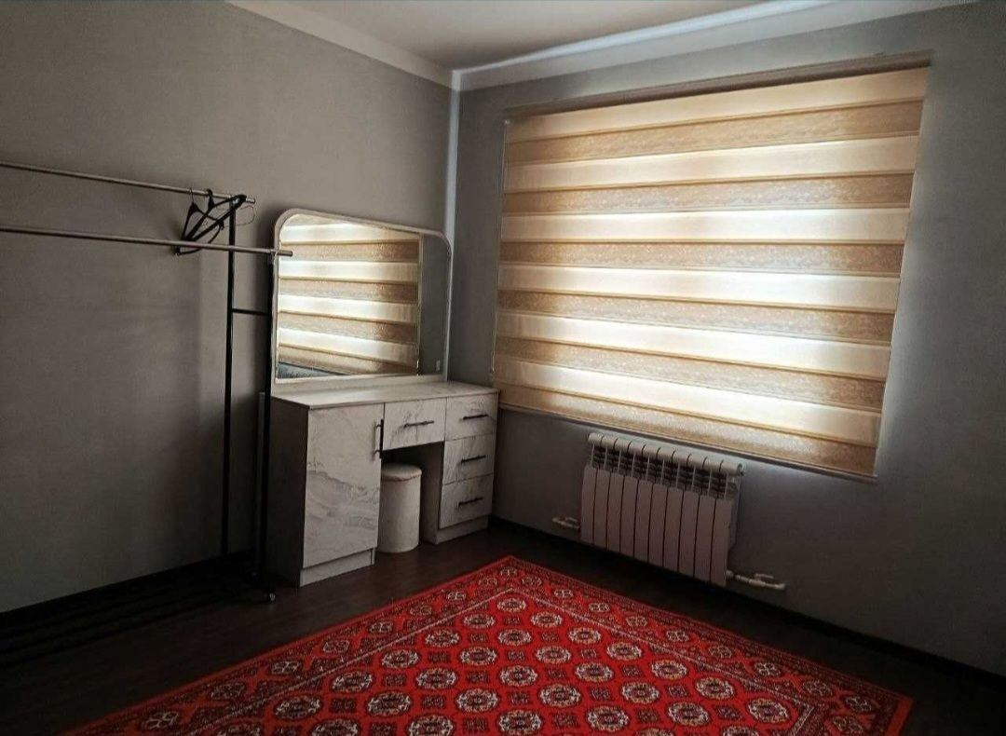 | 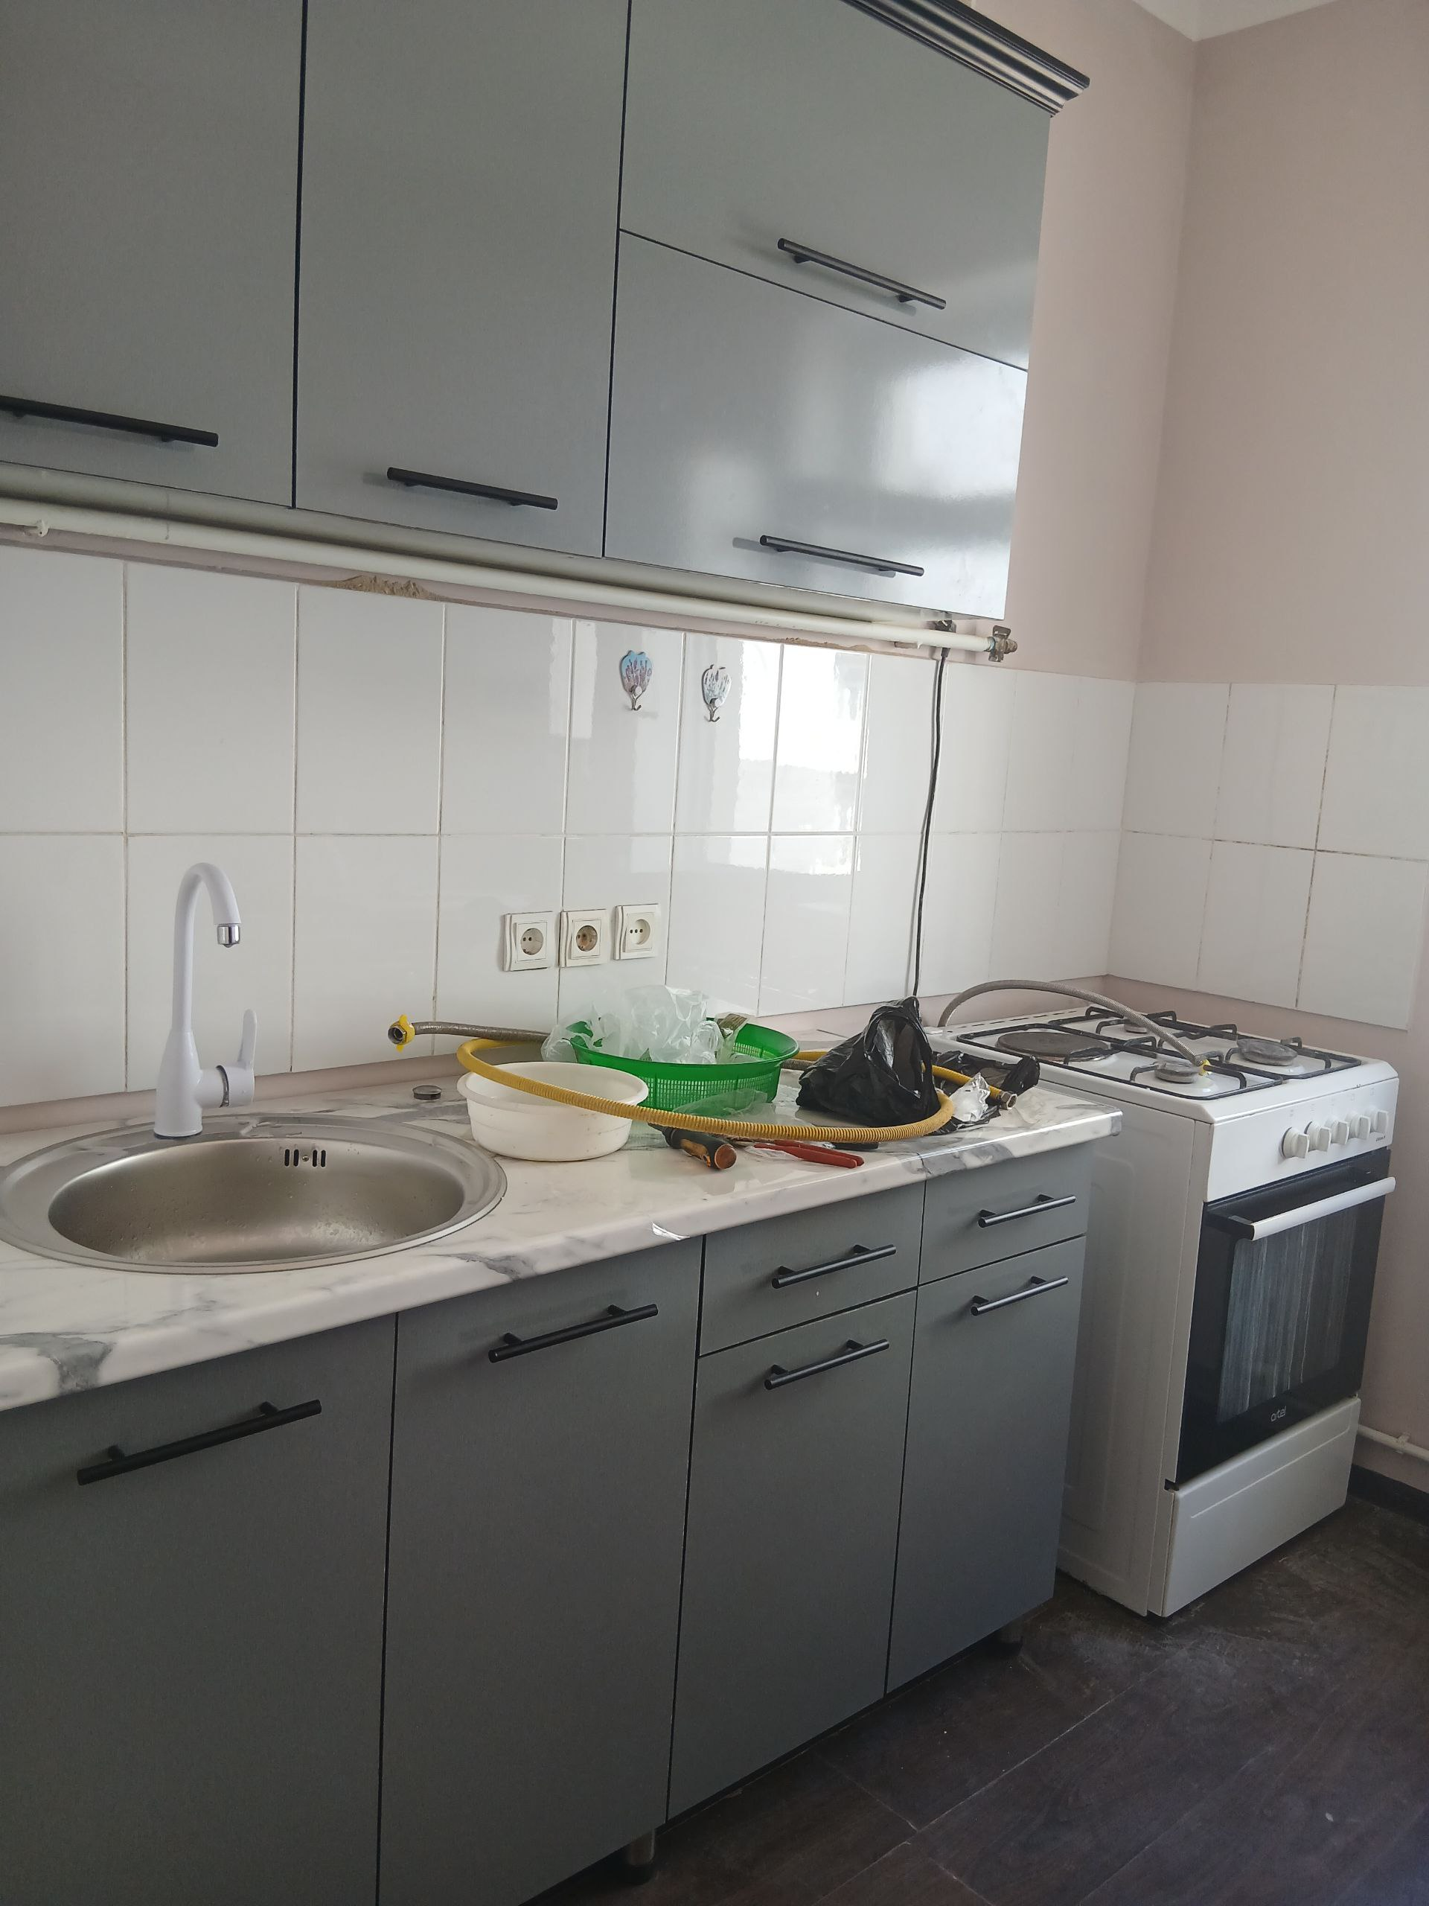
5 | Matrasulova Gulposhsha | Urganch shahar Besh ayvon mahallasi Bobur ko'chasi 16uy | https://maps.google.com/maps?q  =41.571055,60.617642&ll=  41.571055,60.617642&z=16 | 97 515 60 08 | 450000 | 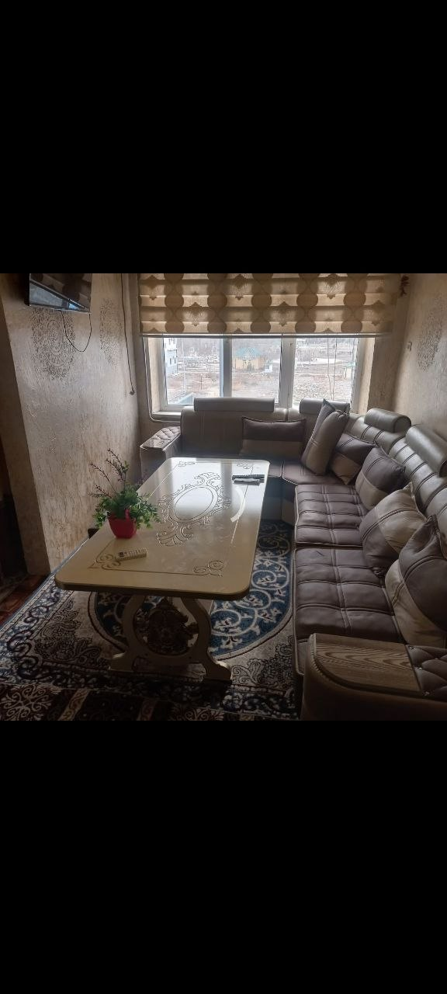 | 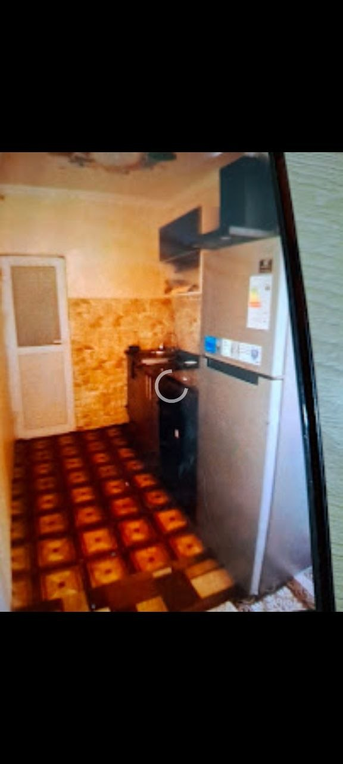
6 | Raximova Farida | Urganch shahar Gurlan ko'chasi 11-dom 39 kvartil | https://maps.google.com/maps?q  =41.567071,60.616109&ll=  41.567071,60.616109&z=16 | 93 923 55 05 | 450000 | 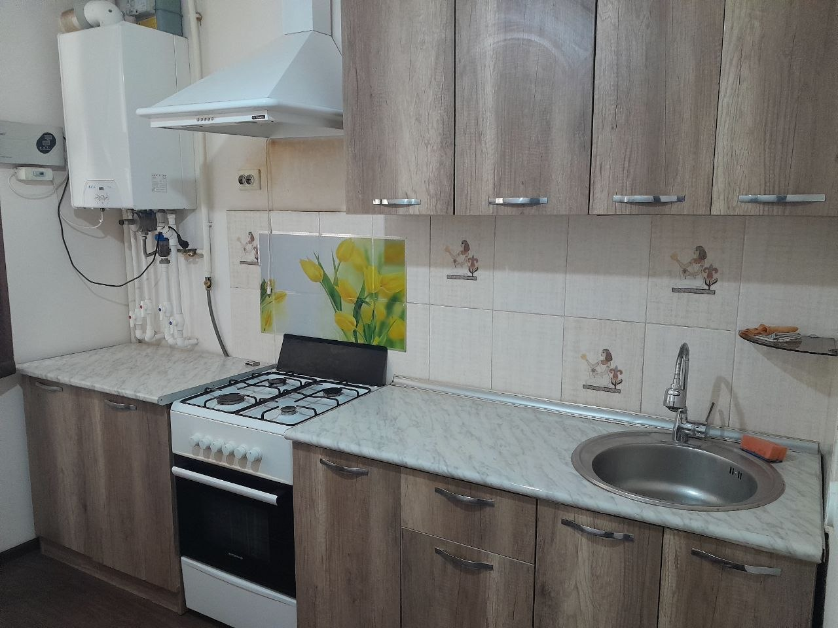 | 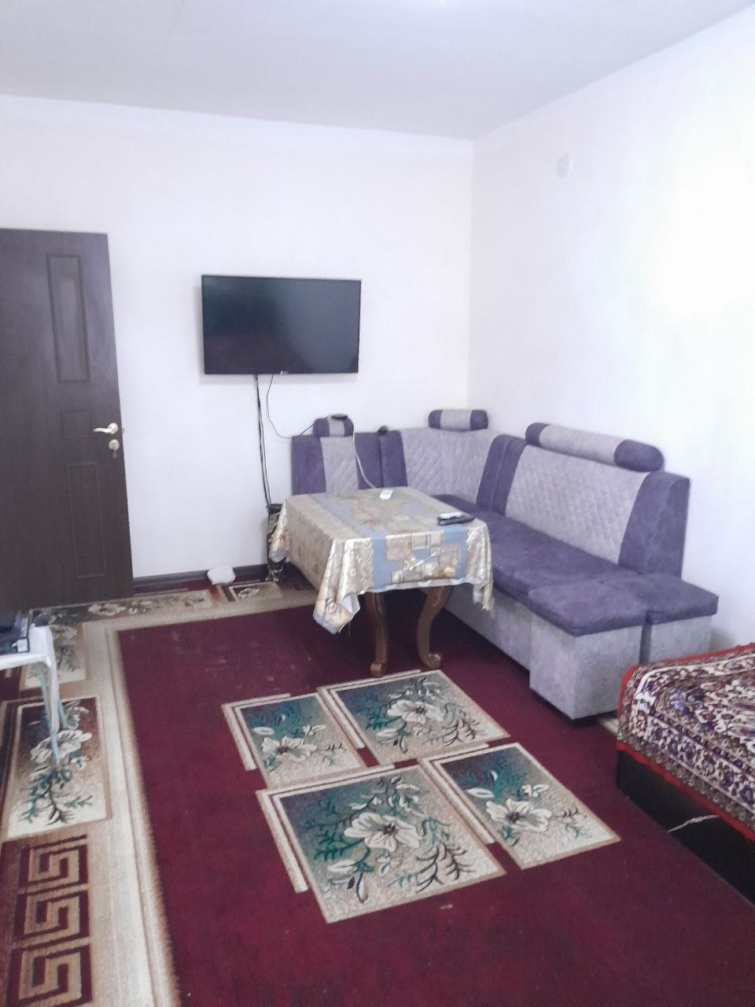
8 | Ollayorova Maqsuda | Urganch shahar Gurlan ko'chasi 11 A uy | Dom 11 A  https://maps.app.goo.gl/NU21KbhE7tGuHiSJ9 | 90 557 48 85 | 400000 | 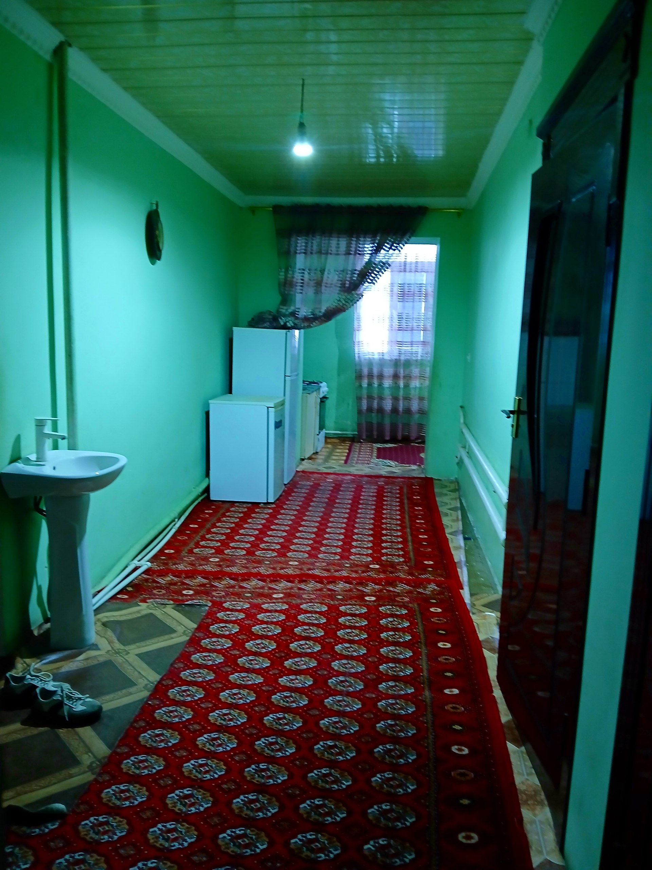 | 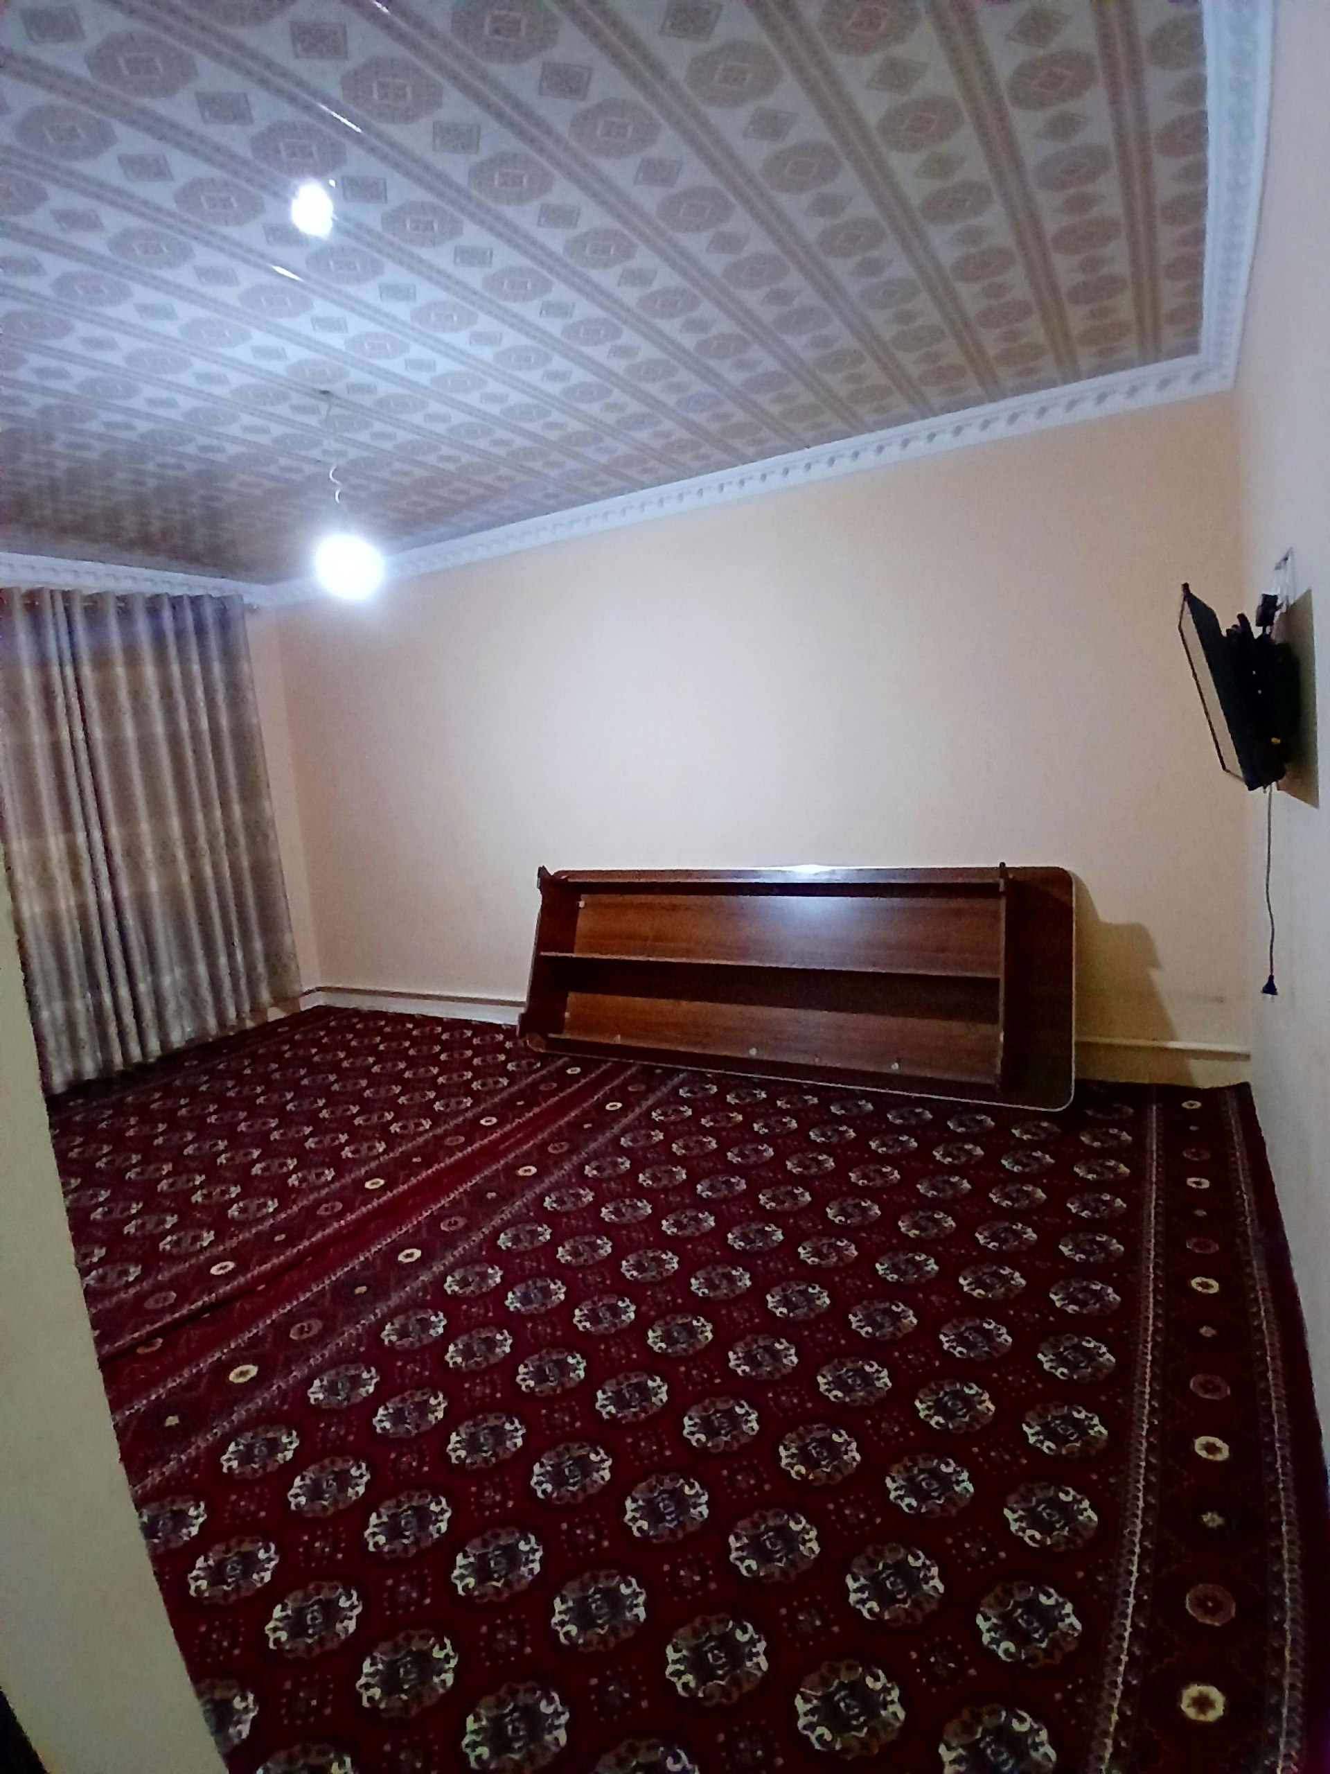
9 | Jumaniyazova Madina | Urhanch shahar Tozabog' mahallasi 9-dom 20-uy | https://maps.app.goo.gl/GHyr1Luwnzmny2pCA | 90 579 23 28 | 400000 | 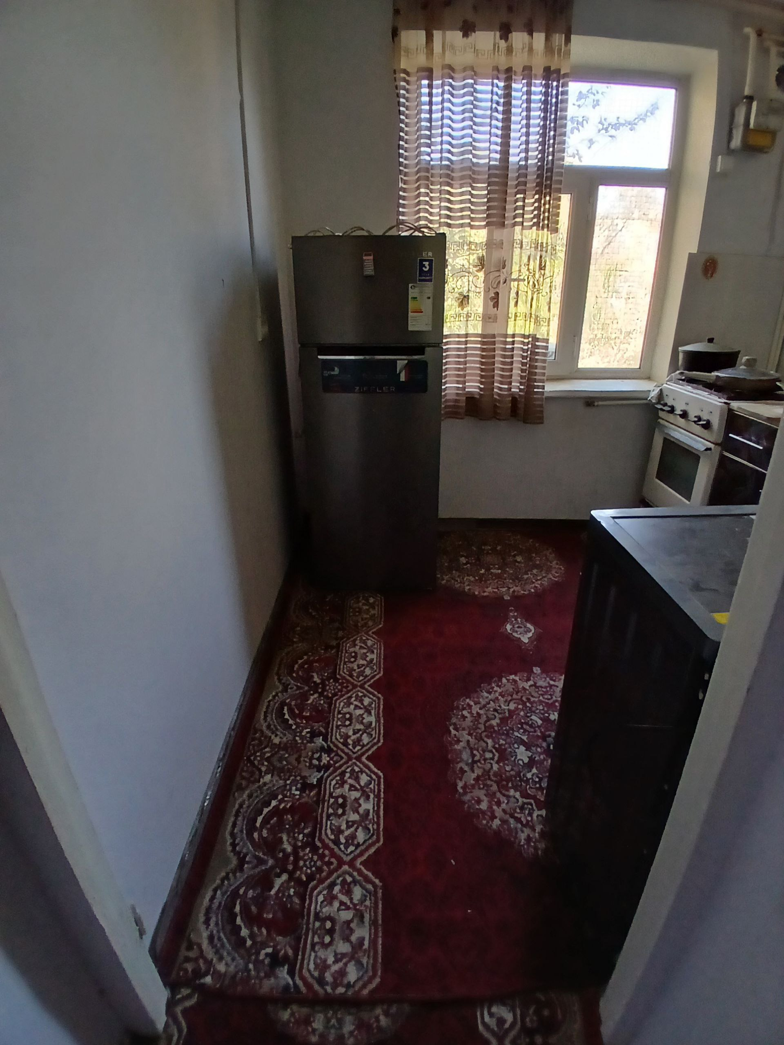 | 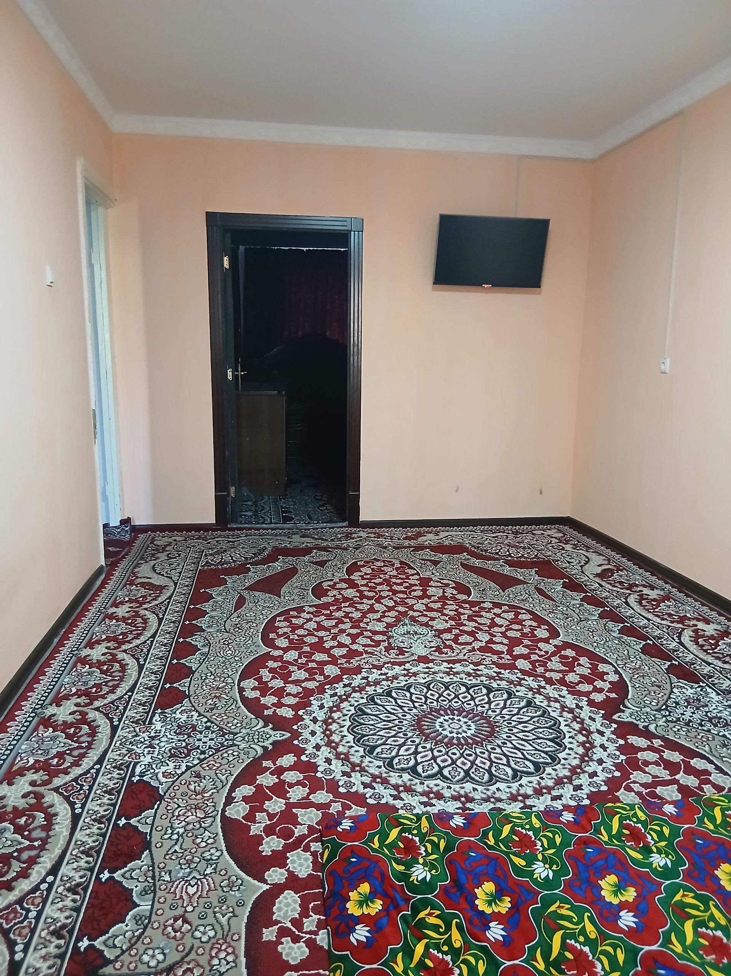
10 | Yusupova Qumrioy | Urganch shahar Gurlan ko'cha 11 A 25-kvartira | https://maps.app.goo.gl/qmQJa4yWrfL1Kg6aA | 99 185 83 79 | 400000 | 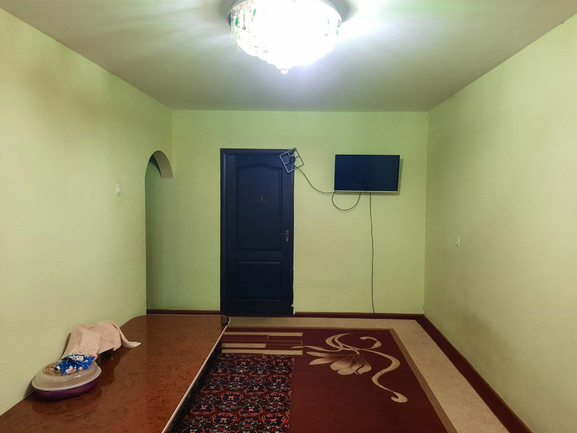 | 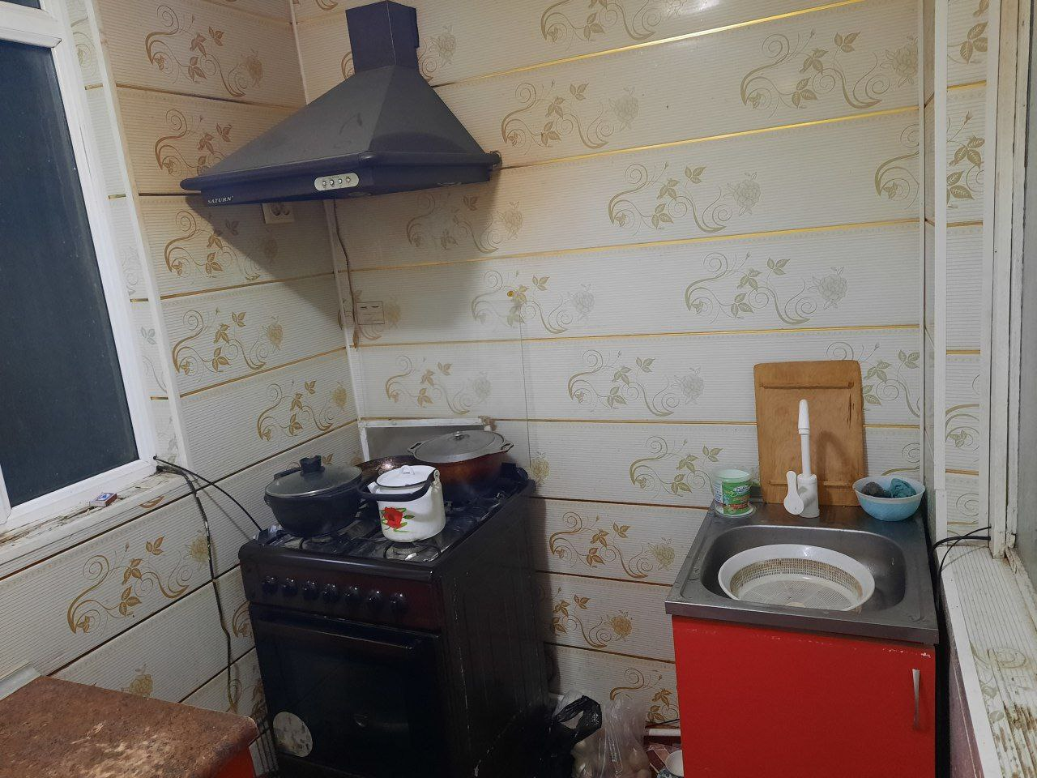
11 | Jabborov Qudrat Ro`zmetovich | Urganch shahar Umid mahallasi Gurlan ko`chasi 11-uy 22-xonadon | https://maps.google.com/maps?q=41.567146,60.615669&ll=41.567146,60.615669&z=16 | +998977902008 | 450000 | 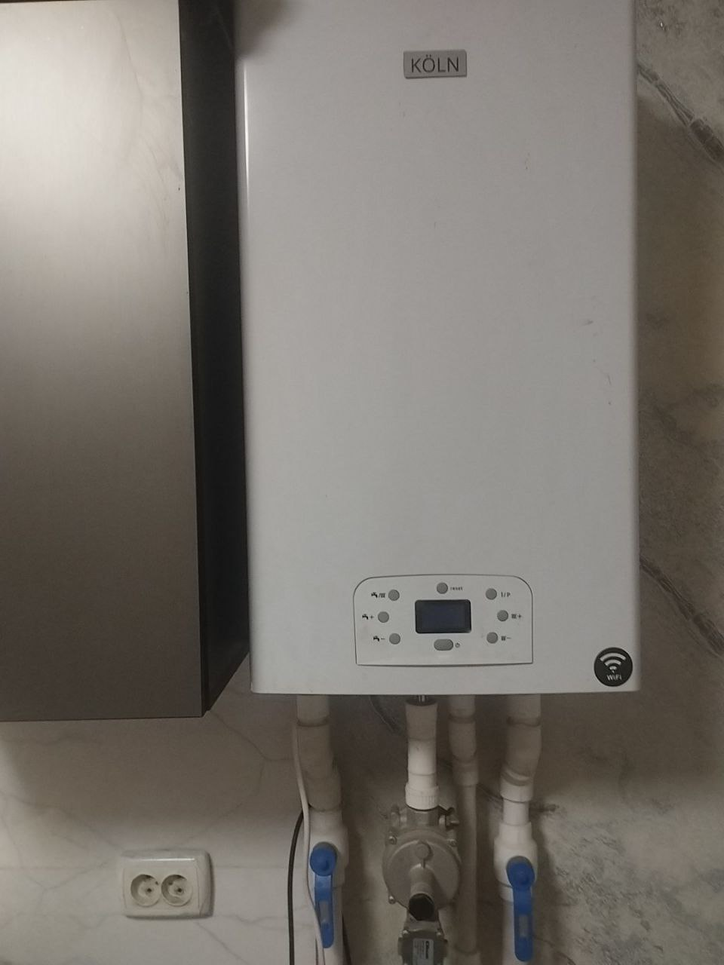 | 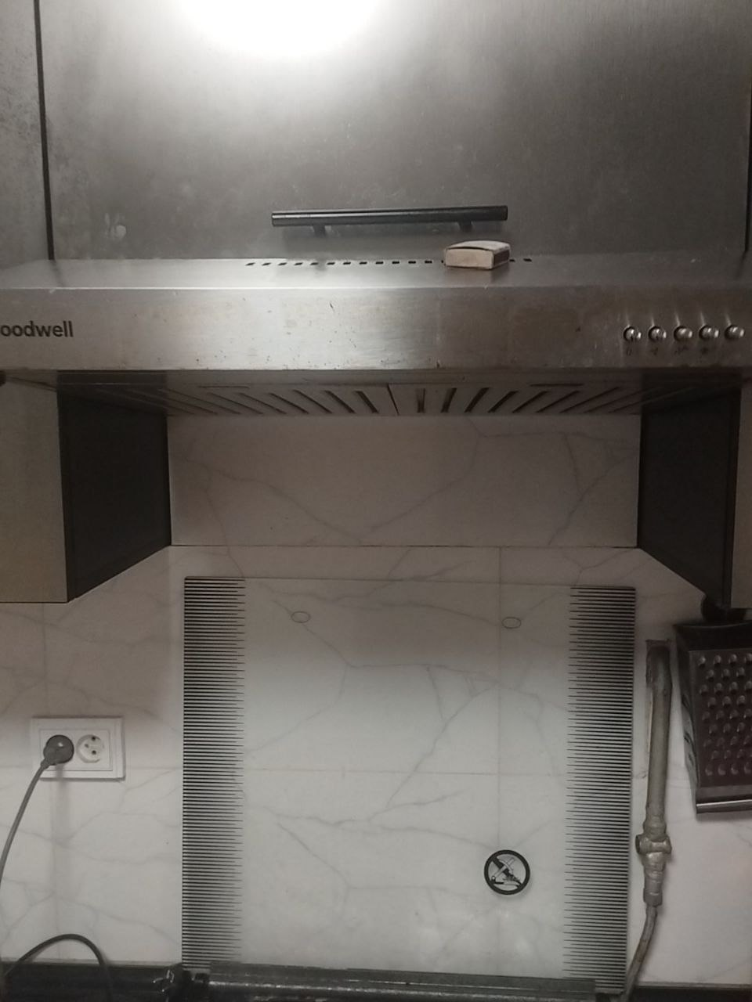
12 | .Yaqubova Sinora | Mustaqillik ko`chasi 32/1 21 kvartira | https://maps.google.com/maps?q=41.567146,60.615669&ll=41.567146,60.615669&z=16 | 881852909 | 450000 | 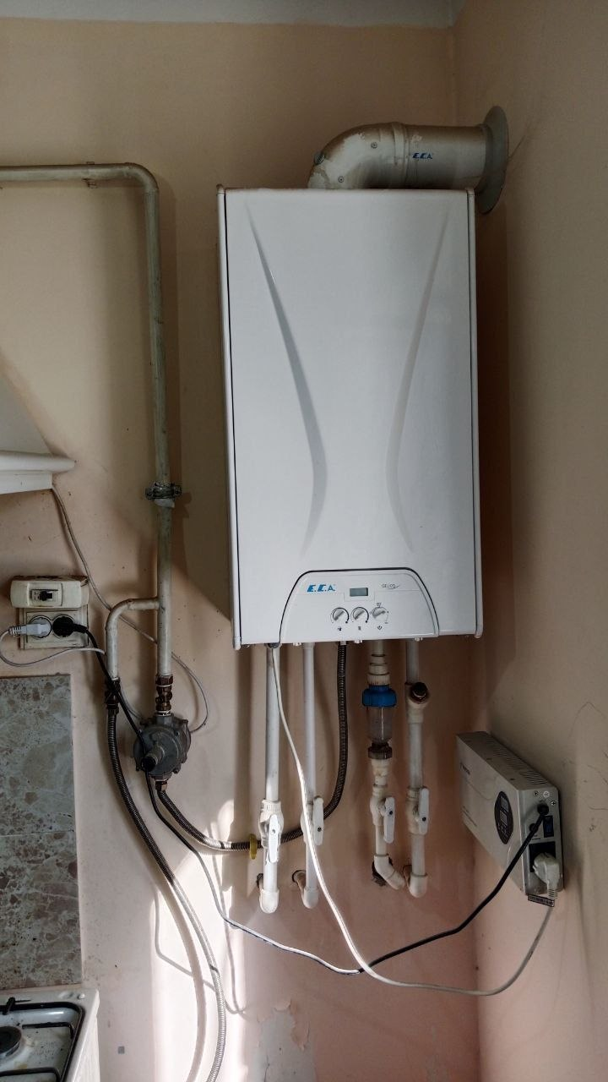
13 | Samandarova Muyassar | Gurlan ko`chasi 17 –uy 16- xonadon | https://maps.google.com/maps?q=41.563882,60.601674&ll=41.563882,60.601674&z=16 | 978697808 | 400000 | 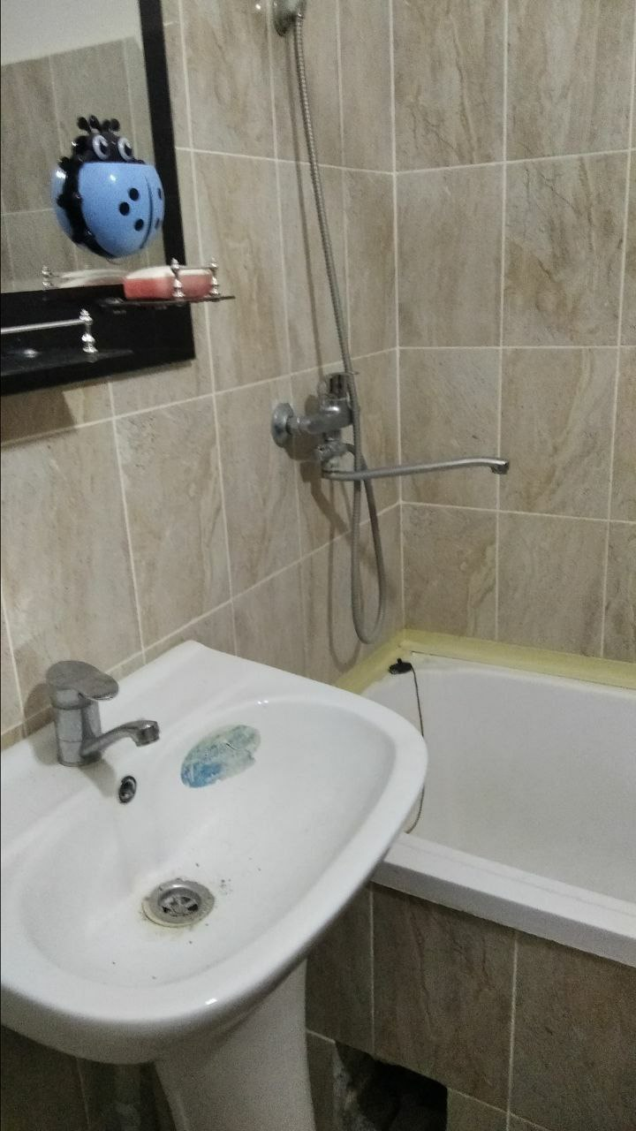
14 | Yavkachova Rano | Tinchlik ko`chasi 2G uy 8 xonadon | https://maps.google.com/maps?q=41.563882,60.601674&ll=41.563882,60.601674&z=16 | 881731955 | 450000 | 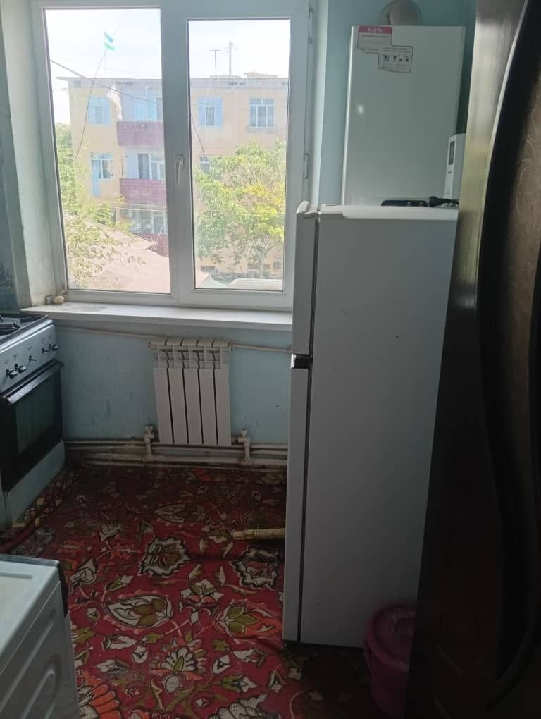
15 | Ibragimov Qadamboy | Nurli hayot m Fayazov ko`chasi 29/7 uy 6-xonadon | https://maps.google.com/maps?q=41.563882,60.601674&ll=41.563882,60.601674&z=16 | 975152741 | 420000 | 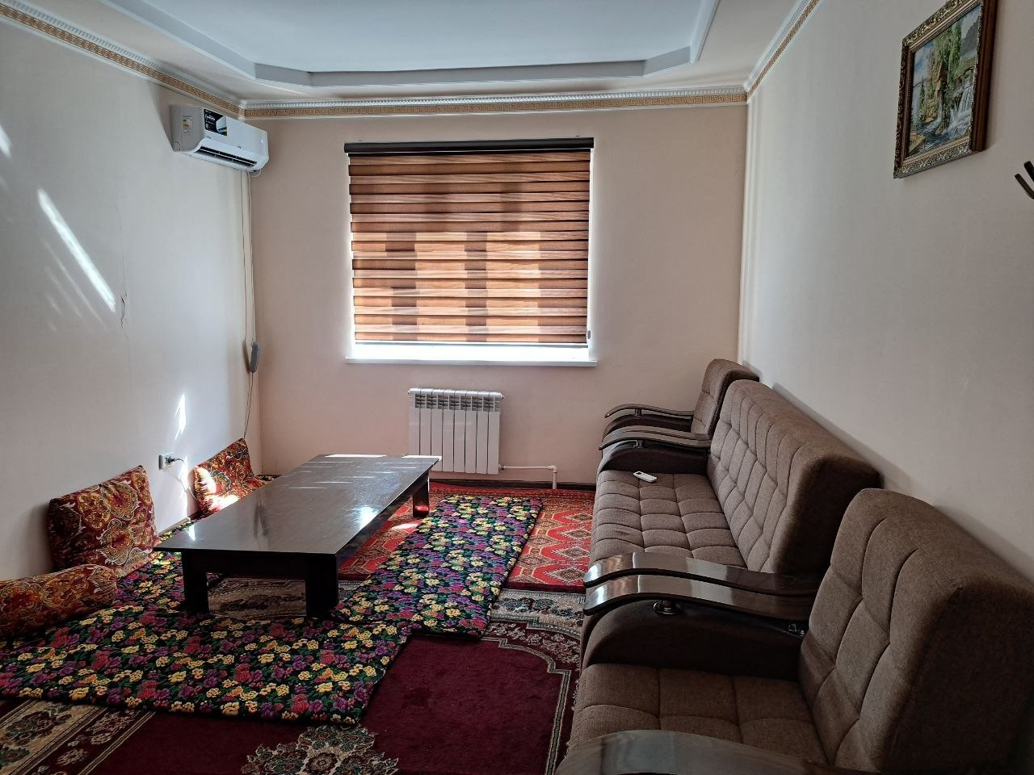
16 | Matsapayev Anvar | Urganch shahar Umid mahallasi Gurlan ko`chasi 19-uy 16-xonadon | https://maps.google.com/maps?q=41.567146,60.615669&ll=41.567146,60.615669&z=16 | +998977902008 | 450000
17 | Ibragimov Qadamboy | Urganch shahar Umid mahallasi Gurlan ko`chasi 11-uy 22-xonadon | https://maps.google.com/maps?q=41.567315,60.613904&ll=41.567315,60.613904&z=16 | +998977902008 | 450000 | 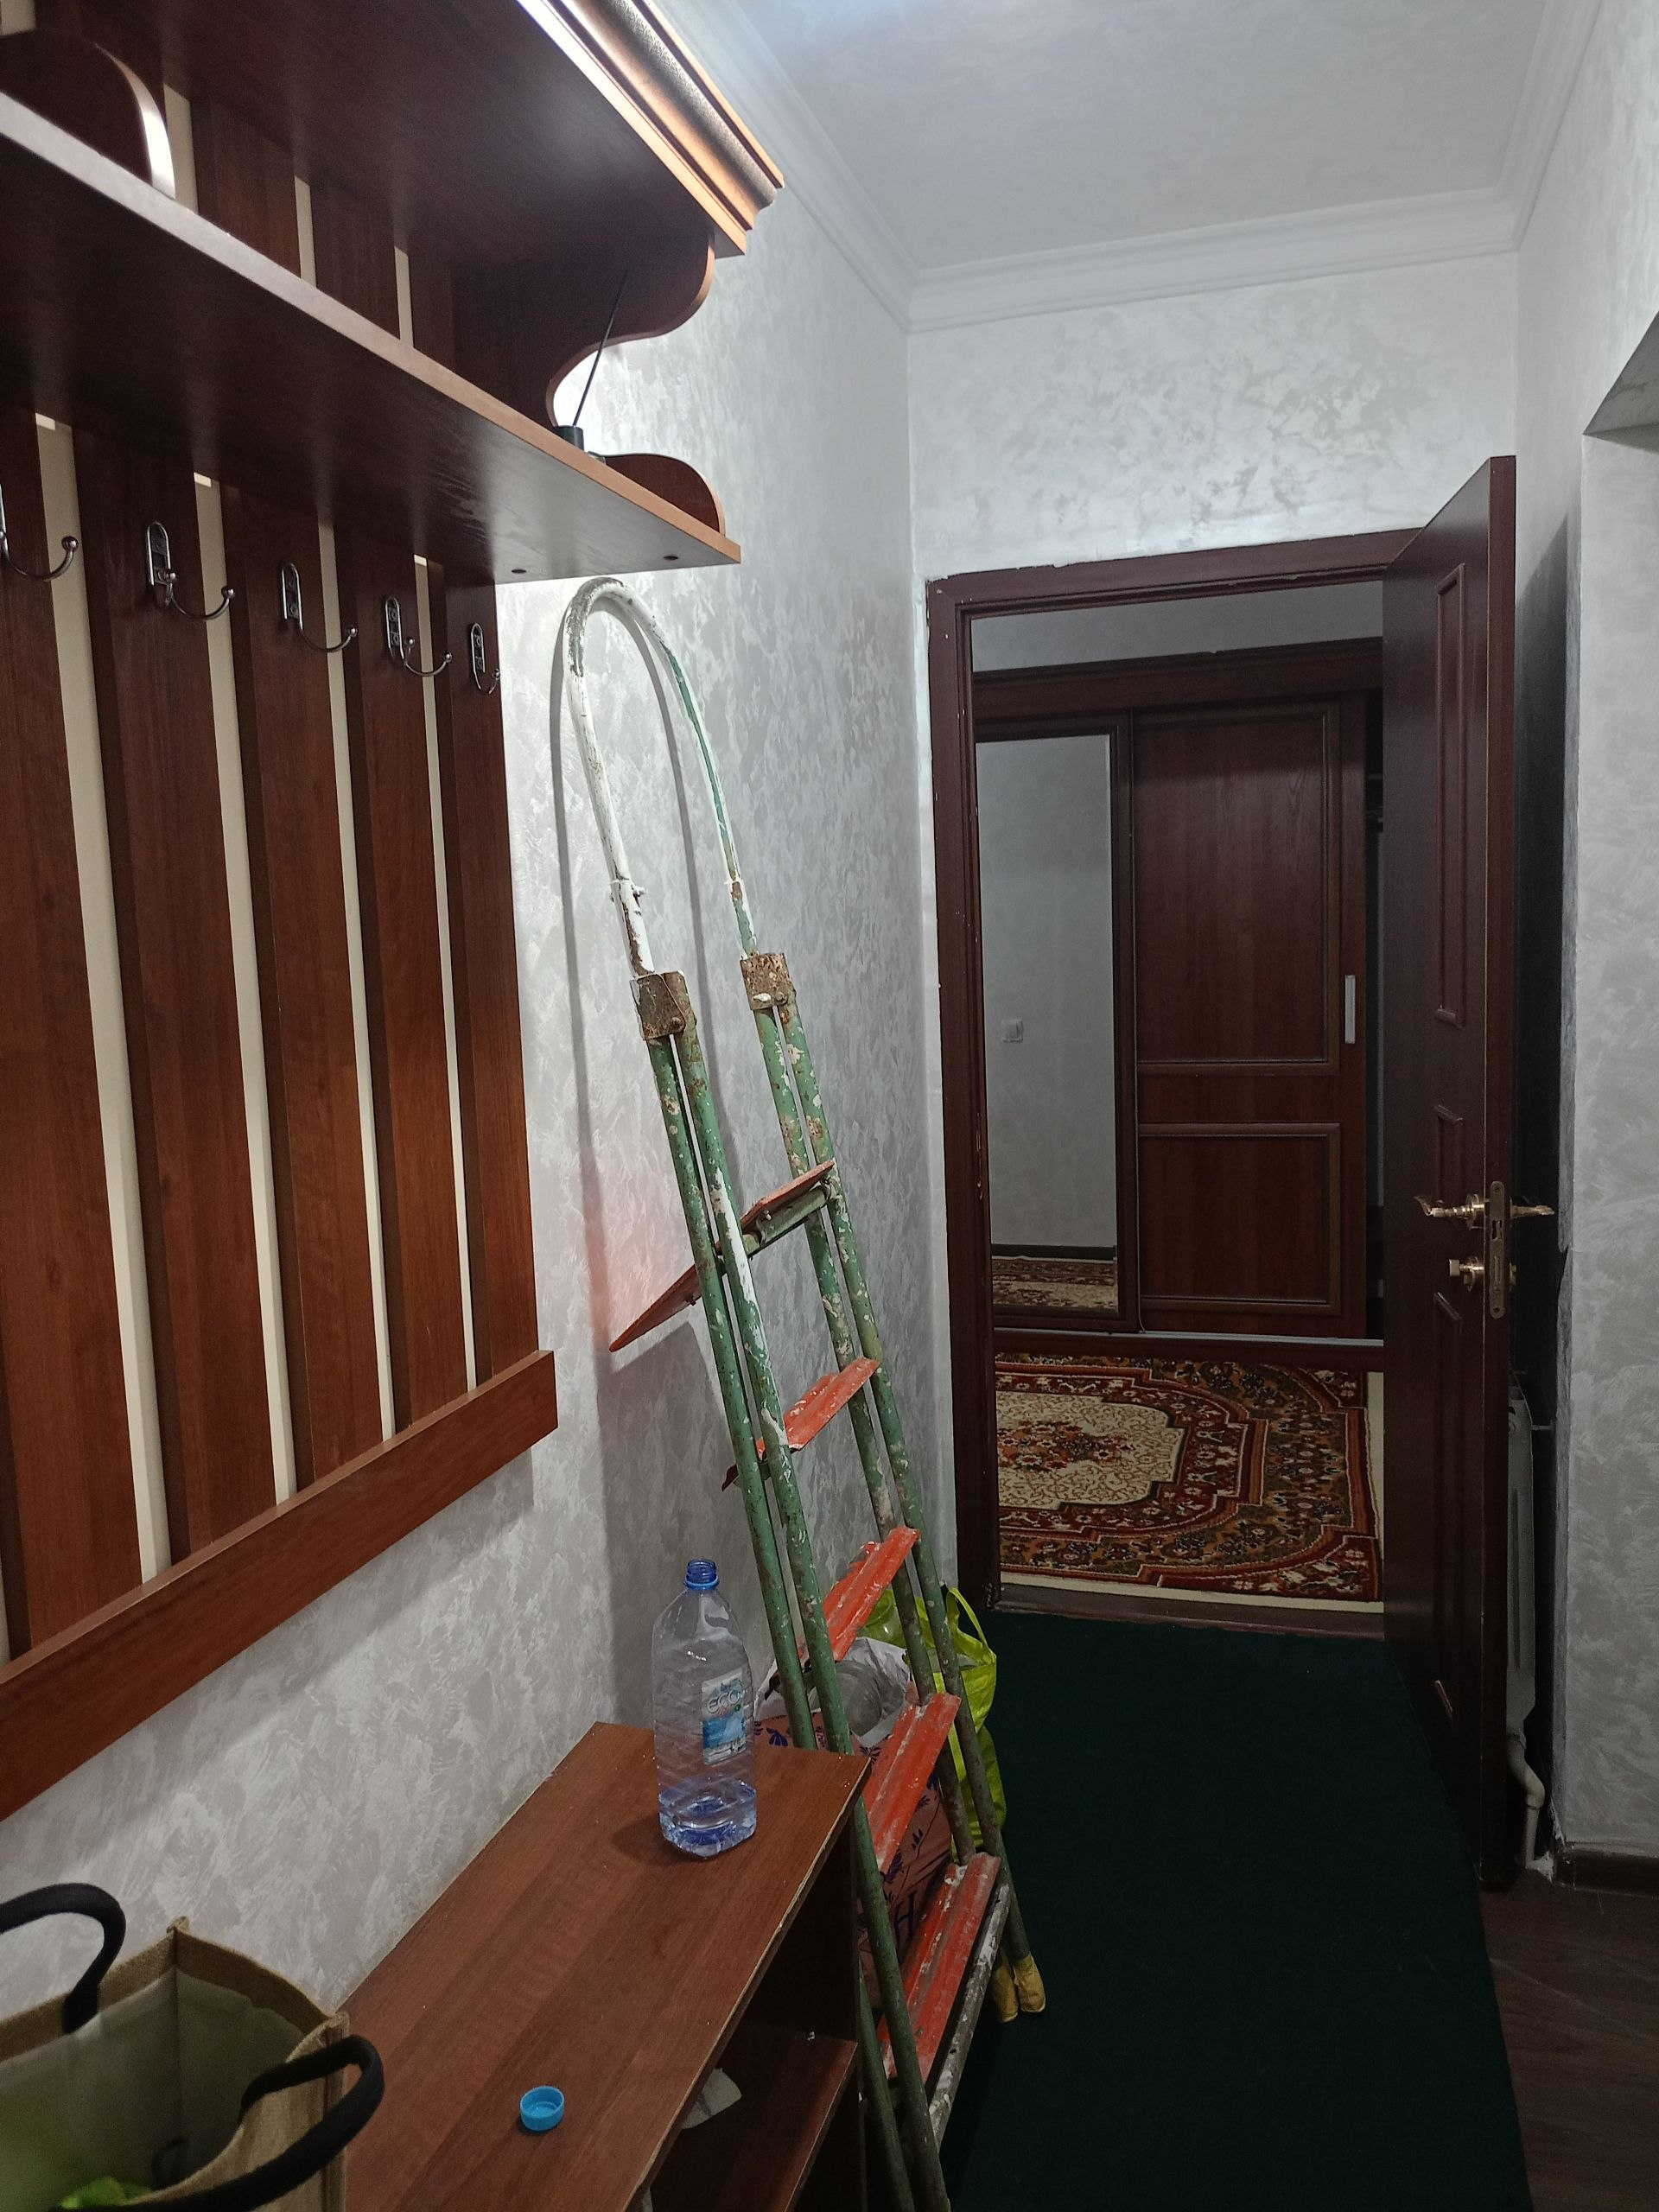 | 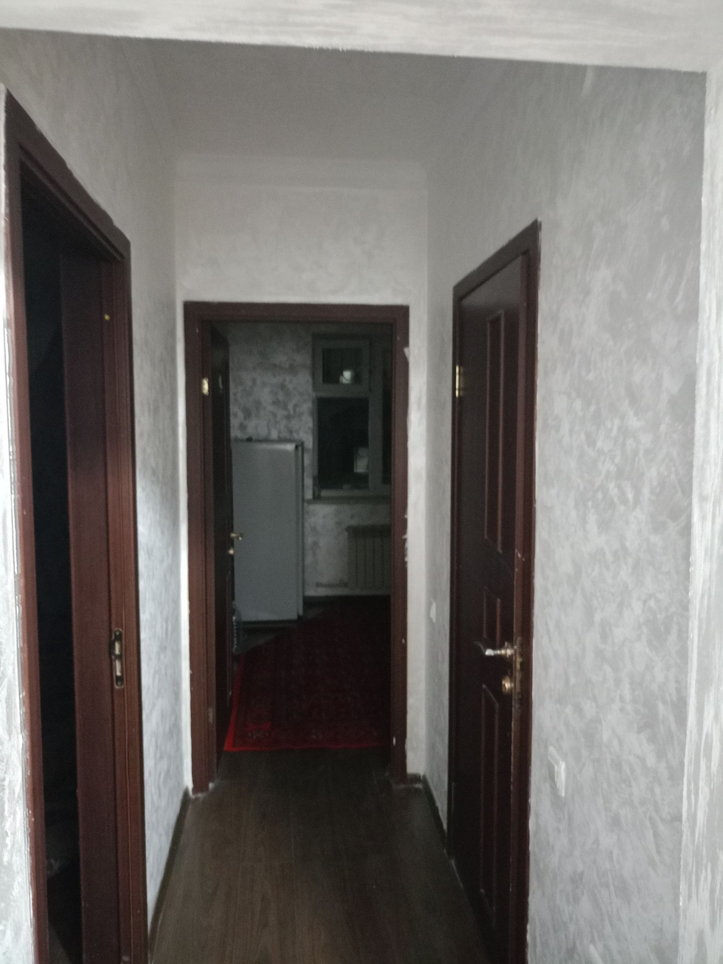
18 | Ibragimov Qodir | Urganch shahri Toza bog' mahallasi  3-mitti tuman  22-uy 4-xonadon  1-yo`lak 2-qavat  (chap taraf | https://maps.google.com/maps?q=41.563882,60.601674&ll=41.563882,60.601674&z=16 | +998997712581 | 450000 | 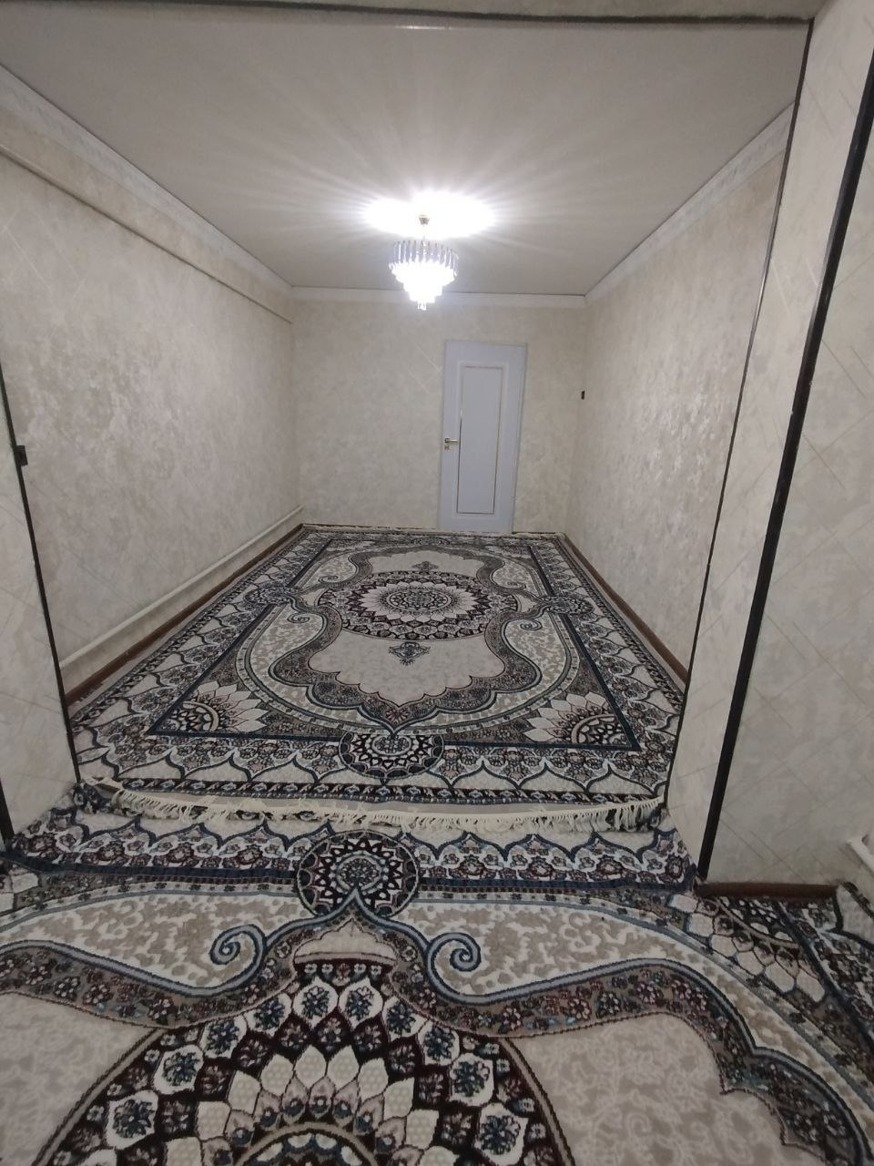 | 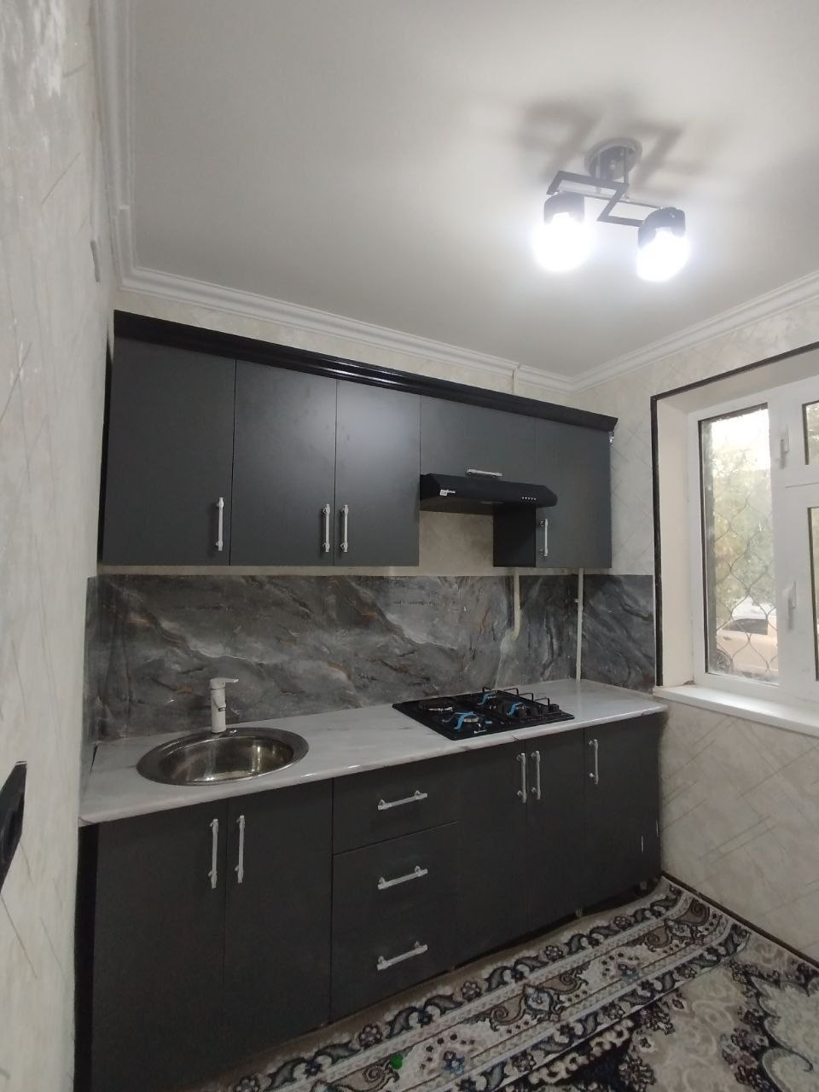
19 | Bazarbayev Joshqin Ro`zmetovich | Urganch shahar  Nurli hayot mahallasi Fayozov ko`chasi  29/7- uy  6-xonadon  2-qavat  (o`ng taraf | https://maps.google.com/maps?q=41.563061,60.608078&ll=41.563061,60.608078&z=16 | +998977903159 | 450000 | 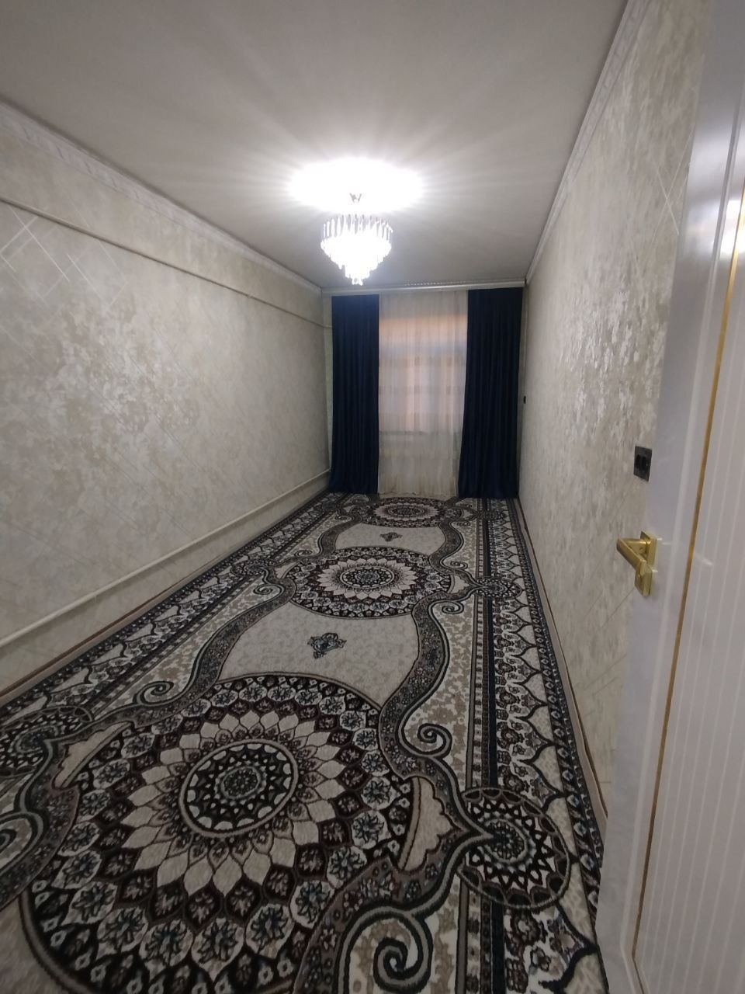
20 | Jabborov Qudrat Ro`zmetovich | Urganch shahar Umid mahallasi Gurlan ko`chasi 37-uy 2-yo`lak 26-xonadon  3-qavat  (chap taraf) | https://maps.google.com/maps?q=41.567714,60.612313&ll=41.567714,60.612313&z=16 | +998930912577 | 400000 | 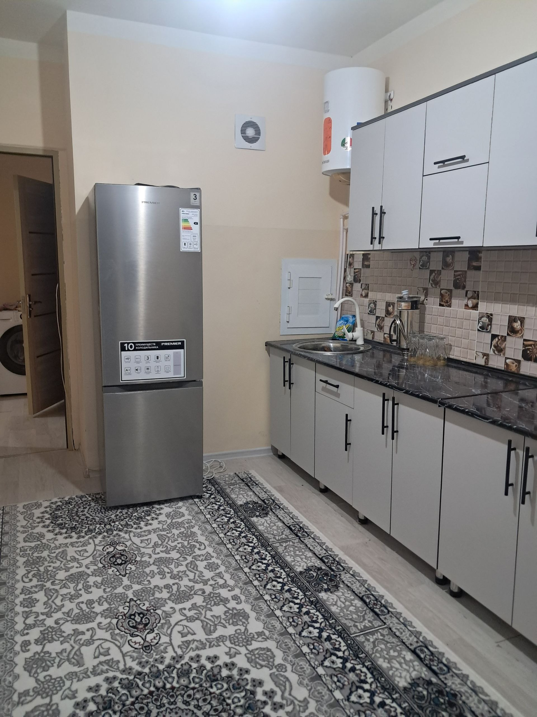 | 