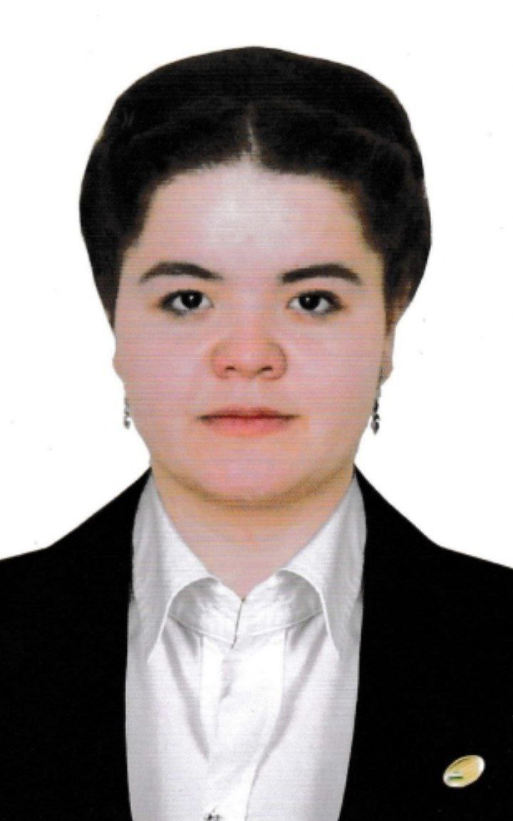

**REFERENCE**

**SultaNOva nodira rashid qizi**

**Date of birth: Place of birth**:

09.02.2003y. Khorezm region, Gurlen district, Ziyakor mahalla

**Nationality:** **Party affiliation:**

Uzbek no

**Education: Graduated:**

Higher Urgench State University

**Education Specialist:** Teacher psychologist

**Academic degree: Academician Degre**:

no no

**What foreign languages ​​she speaks:**

French B1, English B1

**Whether she has state awards:**

Winner of the state scholarship named after Navoi

Whether she is a people's deputy of the republican, regional, city and district Council of Deputies or a member of other elected bodies:

no

**LABOR ACTIVITY**

2023y. - Student at Urgench Medical College.

2023y. - Student, Faculty of Pedagogy, Urgench State University

2024y. - Master's student at Urgench State Pedagogical Institute.